AQI Forecasting System Report

1. Problem Statement

Objective
The primary objective of this project is to accurately predict the Air Quality Index (AQI) for Hanoi, Vietnam, 24 hours into the future.

Background
Air pollution, particularly concerning PM2.5 (fine particulate matter), presents a major public health risk in Hanoi. The local population requires reliable, actionable forecasts to effectively plan outdoor activities and implement necessary protective health measures. This system is designed to address the existing gap in localized, data-driven predictions by integrating historical environmental data with advanced machine learning techniques.

Technical Challenge
This project is defined as a Time-Series Forecasting problem with the following specifications:

- Input: Historical air quality data, including measurements for PM2.5, PM10, and Carbon Monoxide (CO), sourced via the OpenAQ API.
- Output: A numerical prediction representing the maximum AQI value projected for the subsequent day.
- Complexity: Accurate prediction is complicated by factors such as volatile weather patterns, distinct seasonal variations (e.g., crop burning periods), and dynamic urban traffic cycles, rendering simple data extrapolation methods ineffective.

2. System Architecture
The AQI Forecasting System is engineered as a Modular MLOps Platform. The architecture is deployed on AWS EC2, utilizing a microservices pattern where each core function is isolated within a dedicated Docker container. This design choice ensures high levels of portability, robustness, and horizontal scalability.
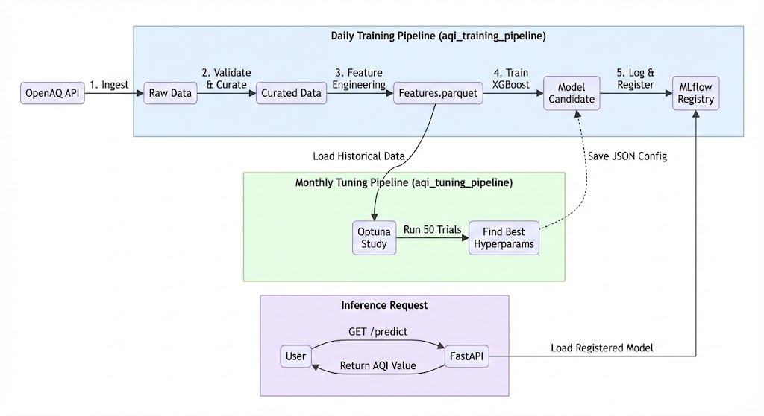
The system components and their functions are detailed in the following table:

Component | Technology | Detailed Purpose
Orchestration | Apache Airflow | The "Traffic Controller" of the system. It schedules tasks (e.g., "Run Ingestion at midnight") and manages dependencies (e.g., "Don't train until data is curated"). It handles automated retries on failure and manages system-wide alerts.
Model Tracking | MLflow | The "Lab Notebook". Every time a model is trained, MLflow records the code version, hyperparameters, and performance metrics (MAE/RMSE). This capability allows for systematic comparison of different model versions to select the optimal one for deployment.
Model Serving | FastAPI | The "Delivery Driver". It wraps the best-trained XGBoost model within a high-performance, asynchronous HTTP server. It serves predictions by receiving JSON requests from users or applications and returning the computed AQI forecast.
Monitoring | Grafana + Prometheus | The "Dashboard". Prometheus is configured to scrape operational metrics (e.g., CPU utilization, API request latency) from all running containers. Grafana visualizes these metrics in real-time charts, providing continuous insight into the health and performance of the serving infrastructure.
Infrastructure | Docker Compose | The "Blueprints". A single YAML configuration file defines how all individual services are launched, how they establish network communication, and how they persist data volumes for state management.

3. Data Pipeline Flow (DAGs)

The logic of the system is encapsulated in Directed Acyclic Graphs (DAGs) running on Airflow.Pipeline Steps Detail:
- Ingest Data (ingest_openaq.py): Connects to the external OpenAQ API, downloads the last 24 hours of measurements for Hanoi, and saves them as raw JSON/CSV.
- Validate & Curate (validate_and_curate.py): Checks data quality. Are there missing hours? Are values realistic (not negative)? If data passes, it cleans it and saves it to a high-performance Parquet format.
- Feature Engineering (build_features.py): Transforms raw numbers into "Features" for the AI. It creates Lags (e.g., "What was the AQI yesterday?") and Rolling Averages (e.g., "Average AQI of last 7 days").
- Train (train.py): Feeds these features into the XGBoost algorithm. The model learns the relationship between past patterns and future AQI.
- Tuning (tune.py): A separate monthly process that runs thousands of experiments to mathematically calculate the optimal settings (Hyperparameters) for the model.
- Model Promotion/Deployment (promote_model.py): Automatically queries MLflow to compare the newly trained model's performance (e.g., RMSE) against the currently deployed model. If the new model is superior, this task flags it as the "Production" version in the MLflow Model Registry, making it ready for the next serving step.
- Inference (inference.py): Retrieves the latest production-ready model, generates the necessary real-time features from the curated data, and computes the 24-hour AQI forecast. The final predicted value is then written to a dedicated database for consumption by the FastAPI serving component.

4. Operational Sequence: Automated Daily Training Loop
This section illustrates the End-to-End MLOps Lifecycle orchestrated by Airflow. The system follows a strict ETL (Extract, Transform, Load) pattern followed by Model Retraining, ensuring that the production model is always trained on the freshest available data.

4.1. Orchestration Logic

The process executes sequentially. Failure in any upstream task (e.g., API outage during Ingestion) immediately halts the pipeline, preventing data corruption in downstream stages.
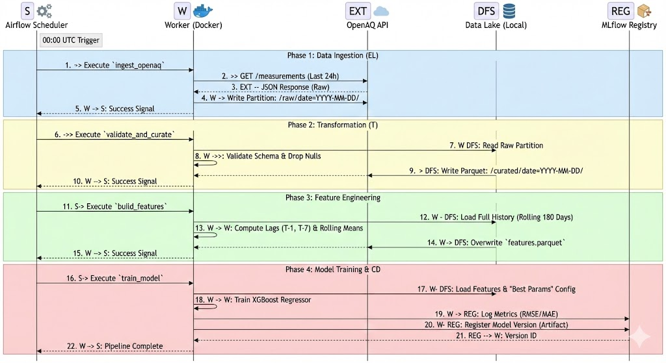

4.2. Detailed Process Breakdown

Phase 1: Ingestion (Extraction & Loading)
- Protocol: HTTPS REST API.
- Action: The system queries the OpenAQ API for the specific geographic coordinates of Hanoi.
- Data Safety: Data is stored in Raw format (immutable JSON/CSV). This creates a "Data Lake" effect, allowing us to re-process historical data differently in the future if needed without re-downloading.
Phase 2: Validation (Transformation)
- Logic: Statistical checks are applied.
  - Completeness Check: Do we have coverage for the requested day?
  - Boundaries Check: Are PM2.5 values non-negative?
- Outcome: Only valid data is promoted to the Curated Layer (Parquet format), optimized for fast reading.
Phase 3: Feature Engineering
- Temporal Logic: The model cannot learn from isolated data points. This step constructs a time-series dataset.
- Operations:
  - Lag Features: Creates input columns like "AQI at this time yesterday" (lag_24h).
  - Traffic Cycles: Creates "AQI at this time last week" (lag_7d) to capture weekly traffic patterns.
Phase 4: Continuous Delivery (Training)
- Dynamic Configuration: The training script injects Hyperparameters (learning rates, tree depths) dynamically provided by the monthly Optuna tuning process.
- Model Registry: The final artifact is not just saved to disk but registered in MLflow. This provides version control for AI (e.g., "Model v45 is active, but v44 was better at predicting weekends").

5. Directory Structure

The codebase is organized by Lifecycle Stage rather than file type. This makes it easy to maintain—if the ingestion breaks, you know exactly where to look.
mvp/
├── infrastructure/ # DevOps Files. Docker Compose, Nginx config, SSH keys.
├── orchestration/ # Data Flow. Airflow DAGs define the order of operations.
├── ingestion/ # Source Connector. Scripts to talk to OpenAQ and validation rules.
├── feature_eng/ # Intelligence. Logic to create smart features from raw data.
├── training/ # Modeling. The core ML code (XGBoost), Tuning script, and logging.
└── serving/ # Product. The API code that end-users actually interact with.

6. Reference
Github: https://github.com/khoitran99/final-mlops-devops.git
Airflow: http://18.138.62.41/airflow
Backend API: http://18.138.62.41/docs
MLflow: http://18.138.62.41/mlflow
Grafana: http://18.138.62.41/grafana

7. Conclusion

The MVP for AQI Forecasting System Report system is fully operational and follows modern MLOps best practices. It successfully automates the entire lifecycle of a machine learning model: from ingesting raw data to deploying a tuned, robust predictor. The modular architecture ensures it is easy to maintain and scale in Phase 4.

